|  |  |
| --- | --- |
|  | **CS 415: Software Engineering**  **Lab Exercise 5 (Thursday 25th July 2024)** |

**Instructions**

You are expected to work in your project teams on this lab exercise.

DO NOT USE ANY AI AGENT in this lab exercise! **[50 POINTS]**

**Submission**: Complete this document with your answers and submit as a team on CANVAS. Here, slots will be created per your teams, such that one submission is assigned to all team members. Nominate one person to submit your completed teamwork.

**Deadline is Wednesday 31st July 2024 at 11:55pm.**

**SYSTEM DESIGN CHALLENGE [50 Points]**

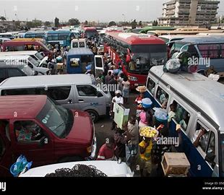

Moving around in Ghana is greatly facilitated by the public transportation system. Vehicles of different sizes from *urvan busses* such as Toyota Hiace, to Mercedes Benz *207*, and then to larger *busses*, are popularly referred to as *TroTro,* are economical means of getting around. Unfortunately, this means of transport is fraught with challenges.

**Tasks**

1. **[10 points]** You are to conduct thorough *research* to identify *three (3)* to *five (5) main challenges* of this transportation system and propose technology-based solutions.

[**Hint**: Provide citations for your research sources]

1. **[40 points]** With your experience in system design, develop a *context* or *high-level diagram* that adequately presents all your solutions above in a very creative and technically sound system composition.

**RUBRIC**

|  |  |  |  |  |  |
| --- | --- | --- | --- | --- | --- |
| **CRITERIA** | **Fail (0)** | **Basic (1-3)** | **Fair (4-6)** | **Good (7-9)** | **Excellent (10)** |
| **Trotro Issues Covered** | None | One or two issues with incoherent explanation | One or two issues with decent and coherent explanation | Three or four/five issues with good and coherent explanation | Five or more very relevant issues with insightful explanation |
| **Number of Citations or Research Sources** | None | One to three citations from questionable sources | Four to six citations from mixed credible sources | Seven to nine/ten citations from mixed credible sources | Ten or more citations from very credible sources |
| **Technical Solution** | None | One to three viable technologies or architectural patterns | Four to six viable technologies or architectural patterns | Seven to nine/ten viable technologies or architectural patterns | Ten or more viable technologies or architectural patterns |
| **Creativity/ Artistry** | None | Basic considerations in creative design of diagram | Fair considerations in creative design of diagram | Good considerations in creative design of diagram | Exceptional considerations in creative design of diagram |

**Appendix**

1. UBER Context Diagram

1. SYSTEM DESIGN (Quality Attribute Mechanisms)

